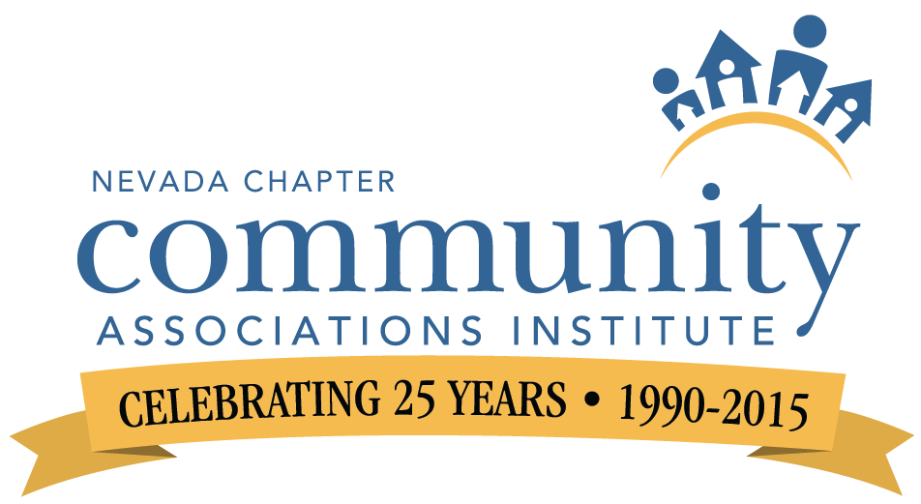

FOR IMMEDIATE REELASE Contact:: Chris Snow
Topic: Charitable Org. Awards Community Associations Institute,
Nevada Chapter
Communications & Marketing
702-648-8408
marketing@cai-nevada.org

Community Associations Institute, Nevada Chapter Accepting Nominations for Annual Ordinary People Extraordinary Measures Awards
(Las Vegas and Reno ) – Community Associations Institute’s Nevada Chapter, an educational organization representing homeowners associations, community managers and industry partners statewide, has
announced they are accepting nominations for individuals and charities statewide. Formerly known as the Annual Heroe’s Luncheon, it was redeveloped in 2012 to honor small charitable organizations that make a difference and are original to Nevada.

Nominations are due May 31, 2015, forms can be found by visiting www.cai-nevada.org, under Events, OPEM Form. (http://www.cai-nevada.org/picture/4312015_nomination_form_opem_submission.pdf)
Winners will be honored during the chapter luncheon on Tuesday, September 8, 2015 at the Gold Coast Hotel & Casino.

About CAI
The Nevada Chapter of the Community Associations Institute is dedicated to educating individual homeowners, neighborhood association volunteers, community managers and industry partners statewide. For more information, visit www.cai-nevada.org.

####

