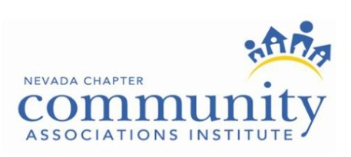

FOR IMMEDIATE RELEASE
Contact: Chris Snow
CAI- Nevada Chapter
702-648-8408
marketing@cai-nevada.org

Community Associations Institute, Nevada Chapter, Announces New Board Members and Committee Chairs for 2015

(Las Vegas and Reno ) – Community Associations Institute’s Nevada Chapter, an educational organization representing homeowners associations, community managers and industry partners statewide, has announced its 2015 board of directors and committee chairs.

The 2015 CAI Nevada board of directors are as follows:
President: James Gibson, Vice President of Business Development, FirstService Residential

President Elect: Mindy Martinez, CIRMS, DCAL, NVEBP, Vice President Commercial Lines Western Risk Insurance
Vice President: Norm Rosensteel, PCAM, NVEBP, President ATC Assessment Collection Group

Secretary: Tiffany Dessaints, CMCA, AMS, PCAM, President / CEO Associa Nevada
South
Treasurer: Donna Toussaint, DCAL, The Lakes Association community leader & volunteer

Directors: Adam Clarkson, Esq., Owner/Principal The Clarkson Law Group, P.C.
Judith Hanson, DCAL, Sun City Aliante, community leader and volunteer
April Parsons, CMCA, AMS, President Prime Community Management, LLC
Michael Schulman, Esq. Partner Wolf Rifkin Shapiro Schulman & Rabkin LLP.

<<MORE>>

In addition, the newly appointed 2015 CAI committee chairs are as follows:

Award Gala chair: Lauren Stemmler, CMCA, AMS
Events chair: Sharon Bolinger, CMCA, AMS, PCAM
Education chair: Katherine Wolfe, CMCA, AMS, PCAM , DCAL
Nevada Educated Business Partner Program chair: Mindy Martinez, CIRMS, DCAL, NVEBP
Education Northern Nevada chair: Lorrie Olson, CMCA, AMS, PCAM, DCAL
Membership chair: Tonya Gale, CMCA
Northern Nevada Committee chair: Beckie Richter
Golf chair: Ken Coats
Magazine chair: Melissa Ramsey, CMCA, AMS, PCAM
CA Day chair: Katherine Apell, CMCA, AMS
Legislative Action Committee: Norm Rosensteel, PCAM, NVEBP & Donna Zanetti, Esq., PCAM
Management Company Executive Advisory: Patricia Taylor, CMCA
Grassroots Committee chair: Kendall Abbott-Luke, CMCA, AMS

Members of the board of directors serve a three-year term, and the committee chairs serve a term of one year. For more information, visit www.cai-nevada.org.

About CAI – Nevada Chapter

The Nevada Chapter of the Community Associations Institute is dedicated to educating individual homeowners, neighborhood association volunteers, community managers and industry partners statewide. For more information, visit www.cai-nevada.org.

###

